Hemisphere-Based Repeated Composite Solids

Definition
# Source: AI Source: Provided by: [Data Path: Persons Table -> ID Column: 1, Name_En Column: Motasem Essam] -> From: [ChatGPT] on [7/25/2026]
Hemisphere-Based Repeated Composite Solids are three-dimensional geometric structures formed by combining two or more hemispheres in a repeated arrangement or pattern.
The hemispheres may have equal or different radii and can be arranged linearly, vertically, radially, in layers, or in other configurations. They may be joined through their flat circular bases, placed together, or combined to form more complex solid structures.
A hemisphere is half of a sphere, produced by cutting a sphere through a plane passing through its center.

Simple Definition
# Source: AI Source: Provided by: [Data Path: Persons Table -> ID Column: 1, Name_En Column: Motasem Essam] -> From: [ChatGPT] on [7/25/2026]
A hemisphere-based repeated composite solid is a geometric structure made by arranging multiple hemispheres in a repeated pattern.

Geometric Representation
# Source: AI Source: Provided by: [Data Path: Persons Table -> ID Column: 1, Name_En Column: Motasem Essam] -> From: [ChatGPT] on [7/25/2026]
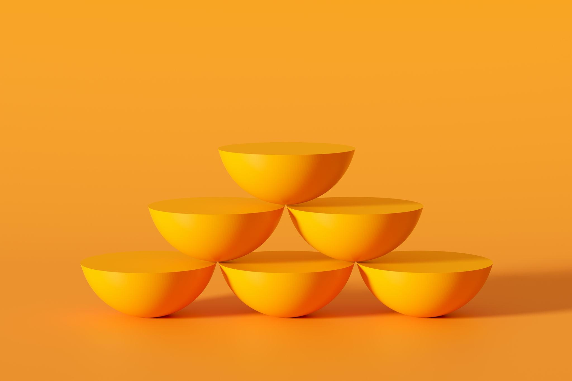
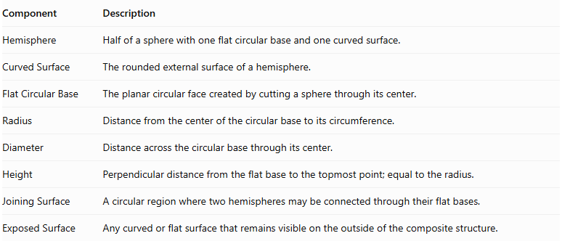
Component | Description
Hemisphere | Half of a sphere with one flat circular base and one curved surface.
Curved Surface | The rounded external surface of a hemisphere.
Flat Circular Base | The planar circular face created by cutting a sphere through its center.
Radius | Distance from the center of the circular base to its circumference.
Diameter | Distance across the circular base through its center.
Height | Perpendicular distance from the flat base to the topmost point; equal to the radius.
Joining Surface | A circular region where two hemispheres may be connected through their flat bases.
Exposed Surface | Any curved or flat surface that remains visible on the outside of the composite structure.

Types of Hemisphere-Based Repeated Composite Solids

Linear Hemisphere-Based Composite Solids
# Source: AI Source: Provided by: [Data Path: Persons Table -> ID Column: 1, Name_En Column: Motasem Essam] -> From: [ChatGPT] on [7/25/2026]
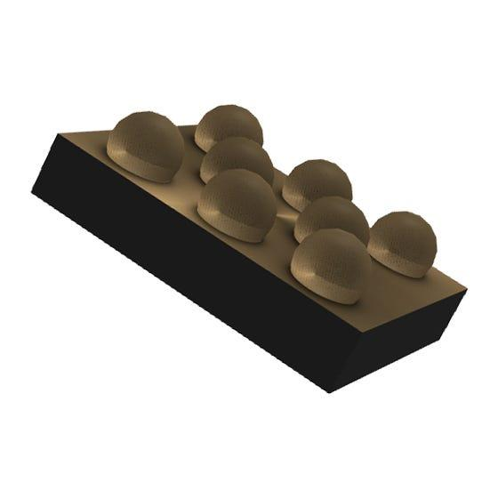
Two or more hemispheres arranged consecutively along a straight line.
- The hemispheres may have equal or different radii.
- Their flat bases may face the same direction or alternate directions.
- They may be connected through their flat circular bases or arranged in a repeated sequence.

Stacked Hemisphere-Based Composite Solids
# Source: AI Source: Provided by: [Data Path: Persons Table -> ID Column: 1, Name_En Column: Motasem Essam] -> From: [ChatGPT] on [7/25/2026]
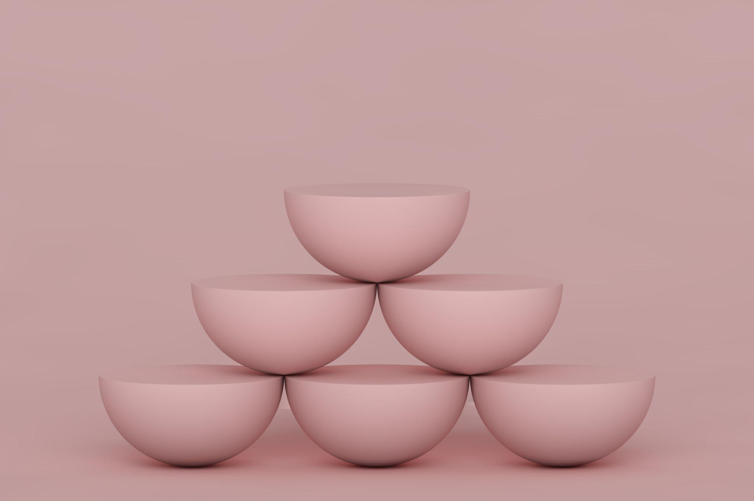
Hemispheres arranged vertically in successive layers.
- Each layer contains one or more hemispheres.
- The arrangement may be symmetrical or asymmetrical.
- Flat-base connections may be used between successive components.

Base-to-Base Hemisphere-Based Composite Solids
# Source: AI Source: Provided by: [Data Path: Persons Table -> ID Column: 1, Name_En Column: Motasem Essam] -> From: [ChatGPT] on [7/25/2026]
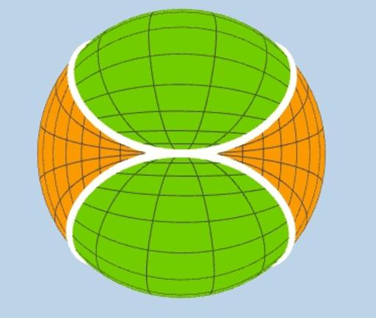
Two hemispheres joined through their flat circular bases.
- Two identical hemispheres joined base-to-base form a complete sphere.
- The joining circular surface becomes internal and is not part of the external surface area.
- Multiple pairs can be arranged in repeated patterns.

Curved-Surface-to-Base Hemisphere-Based Composite Solids
# Source: AI Source: Provided by: [Data Path: Persons Table -> ID Column: 1, Name_En Column: Motasem Essam] -> From: [ChatGPT] on [7/25/2026]
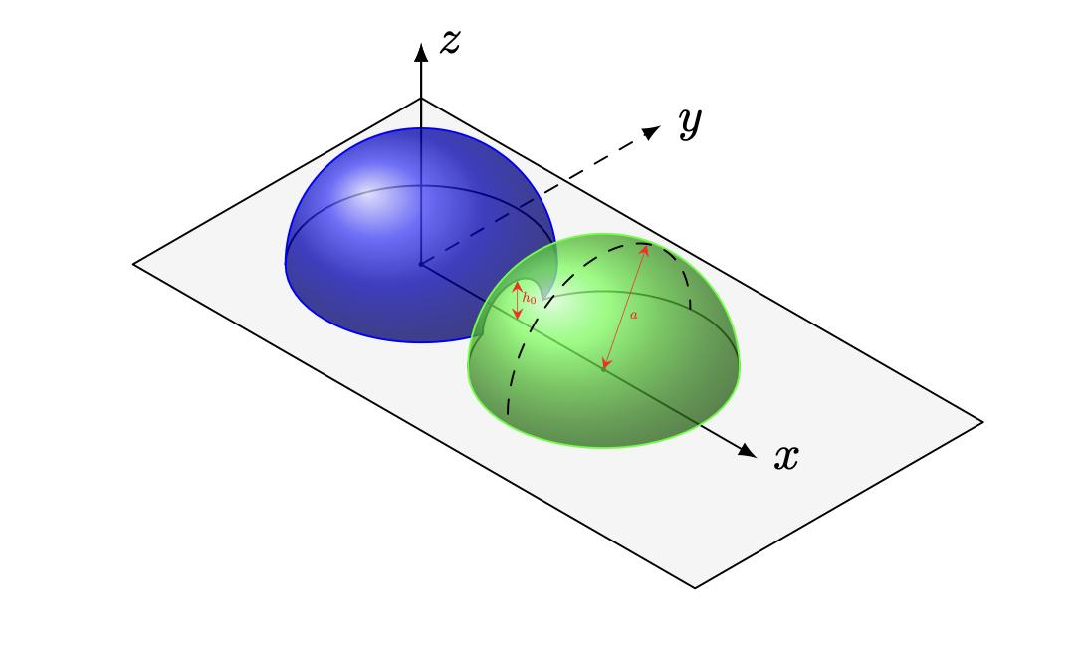
Hemispheres arranged so that the flat base of one hemisphere contacts a region of another hemisphere's curved surface.
- The contact region may be partial.
- The arrangement can produce irregular external boundaries.
- Surface-area calculations require identifying the actual hidden contact regions.

Side-by-Side Hemisphere-Based Composite Solids
# Source: AI Source: Provided by: [Data Path: Persons Table -> ID Column: 1, Name_En Column: Motasem Essam] -> From: [ChatGPT] on [7/25/2026]

Two or more hemispheres placed beside one another.
- Their flat bases may lie in the same plane.
- Their curved surfaces may face the same or opposite directions.
- The hemispheres may have equal or different dimensions.

Radial Hemisphere-Based Composite Solids
# Source: AI Source: Provided by: [Data Path: Persons Table -> ID Column: 1, Name_En Column: Motasem Essam] -> From: [ChatGPT] on [7/25/2026]
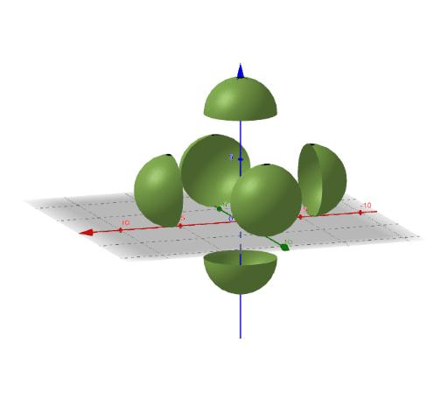
Hemispheres arranged around a central region or axis.
- Components are distributed outward from a central position.
- The arrangement may be rotationally symmetrical.
- It can form flower-like or circular patterns.

Layered Hemisphere-Based Composite Solids
# Source: AI Source: Provided by: [Data Path: Persons Table -> ID Column: 1, Name_En Column: Motasem Essam] -> From: [ChatGPT] on [7/25/2026]
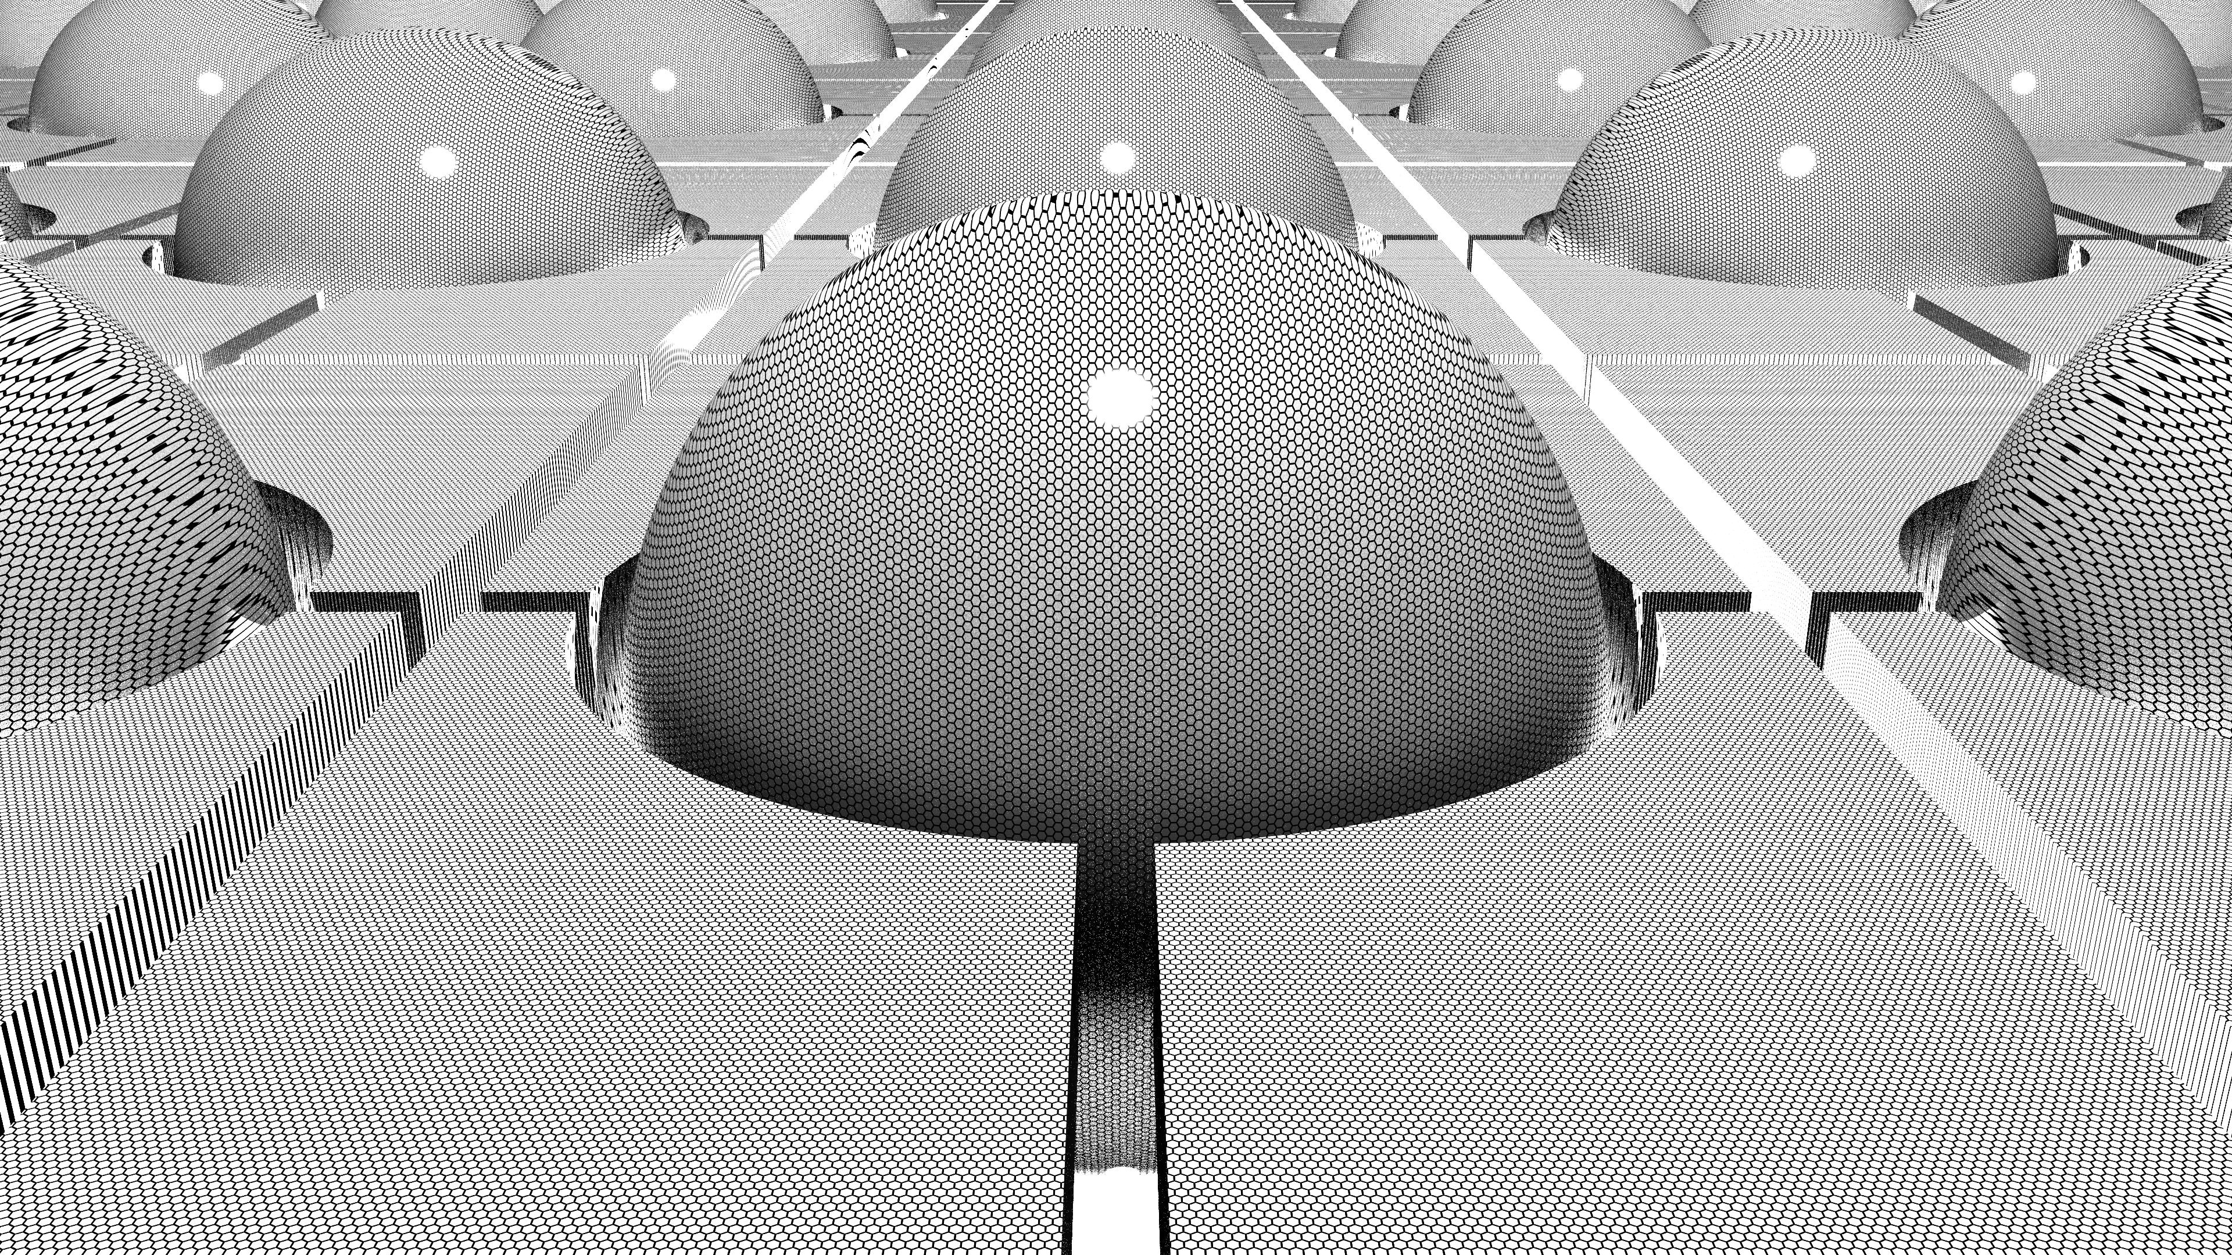
Hemispheres arranged in two or more horizontal or inclined layers.
- Each layer contains repeated hemispherical components.
- Layers may contain equal or different numbers of hemispheres.
- The arrangement may be aligned or staggered.

Clustered Hemisphere-Based Composite Solids
# Source: AI Source: Provided by: [Data Path: Persons Table -> ID Column: 1, Name_En Column: Motasem Essam] -> From: [ChatGPT] on [7/25/2026]
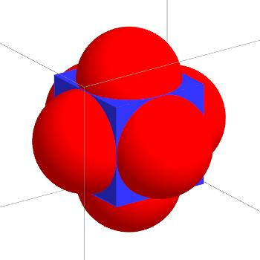
Multiple hemispheres grouped together in a compact arrangement.
- Components may have different orientations.
- The cluster may be regular or irregular.
- Some components may touch while others remain separate.

Grid-Based Hemisphere-Based Composite Solids
# Source: AI Source: Provided by: [Data Path: Persons Table -> ID Column: 1, Name_En Column: Motasem Essam] -> From: [ChatGPT] on [7/25/2026]
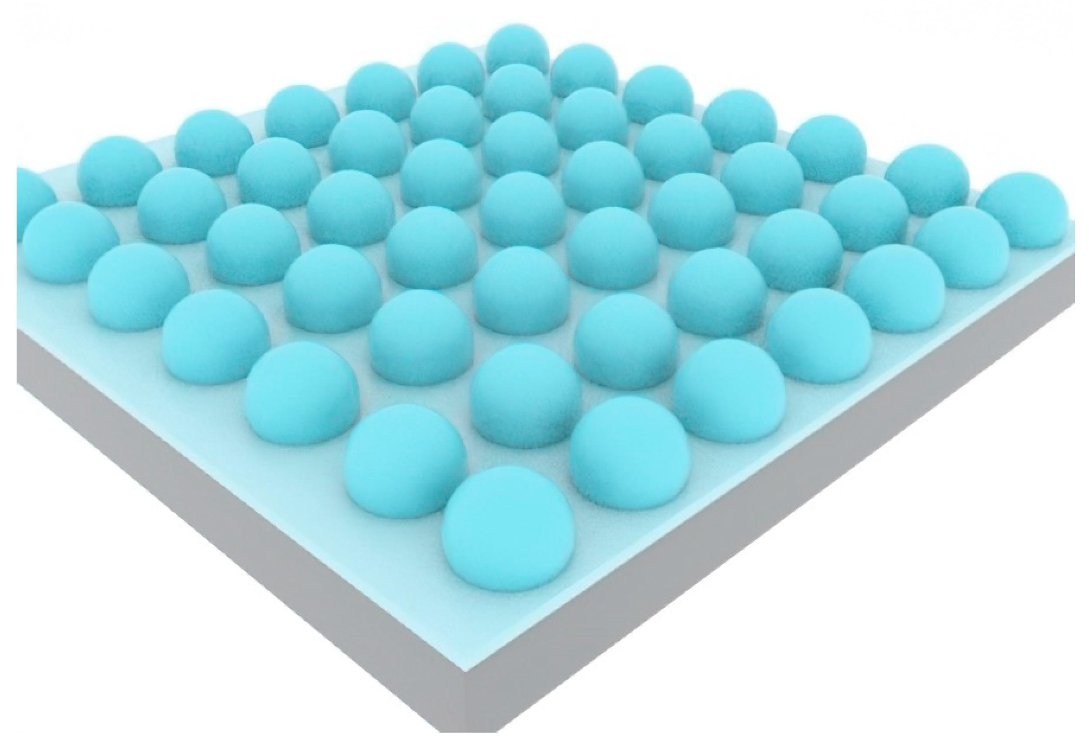
Hemispheres arranged in rows and columns to create a regular grid.
- Each row contains a repeated number of hemispheres.
- Rows may be aligned or staggered.
- The grid may extend horizontally or across multiple levels.

Nested Hemisphere-Based Composite Solids
# Source: AI Source: Provided by: [Data Path: Persons Table -> ID Column: 1, Name_En Column: Motasem Essam] -> From: [ChatGPT] on [7/25/2026]
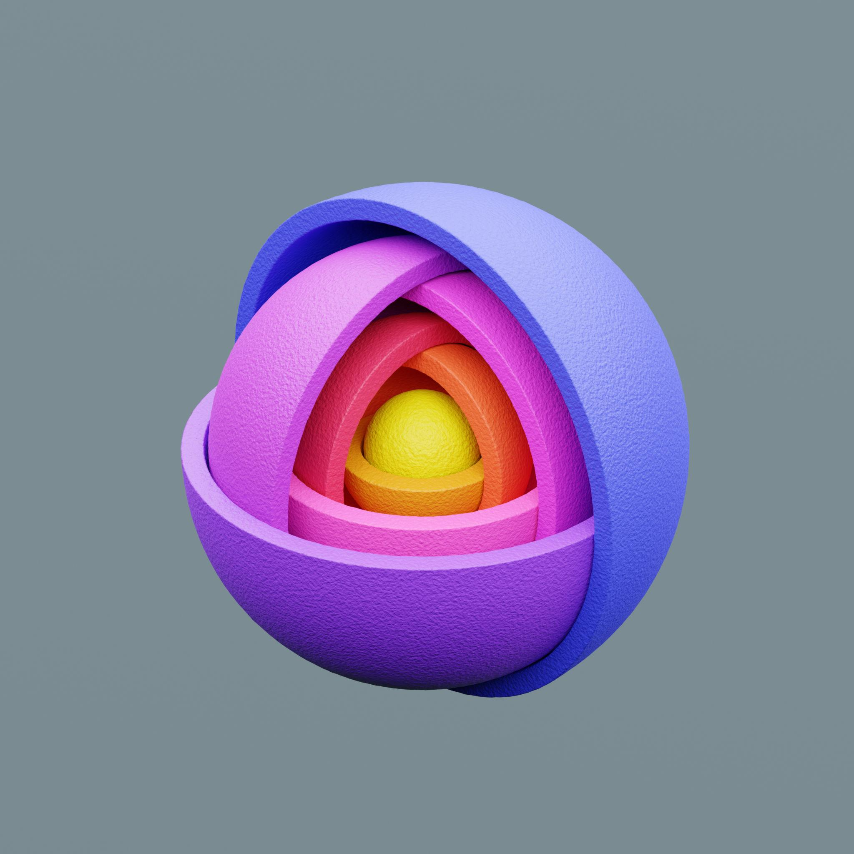
Two or more hemispherical components arranged one inside another.
- The components may share a common center and axis.
- Different radii create nested hemispherical shells.
- The structure may be solid or hollow.

Symmetrical Hemisphere-Based Composite Solids
# Source: AI Source: Provided by: [Data Path: Persons Table -> ID Column: 1, Name_En Column: Motasem Essam] -> From: [ChatGPT] on [7/25/2026]

Hemispheres arranged according to one or more symmetry planes or axes.
- Components may be distributed equally on opposite sides.
- Their dimensions and orientations may be identical.
- The arrangement may have reflectional or rotational symmetry.

Irregular Hemisphere-Based Composite Solids
# Source: AI Source: Provided by: [Data Path: Persons Table -> ID Column: 1, Name_En Column: Motasem Essam] -> From: [ChatGPT] on [7/25/2026]
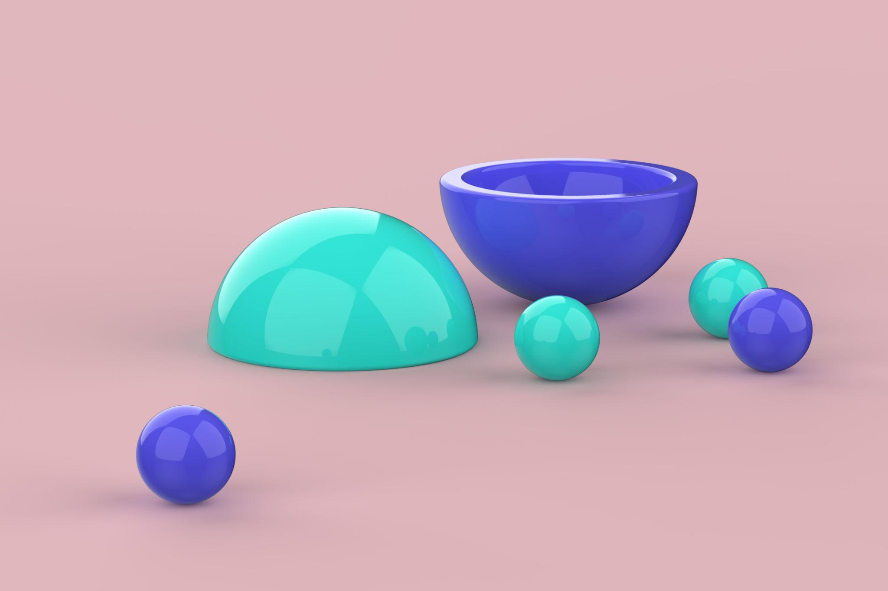
Hemispheres arranged without a consistent repeated geometric pattern.
- Components may have different radii.
- Their positions and orientations may vary.
- The resulting structure may be asymmetrical.

Classification by Arrangement
# Source: AI Source: Provided by: [Data Path: Persons Table -> ID Column: 1, Name_En Column: Motasem Essam] -> From: [ChatGPT] on [7/25/2026]
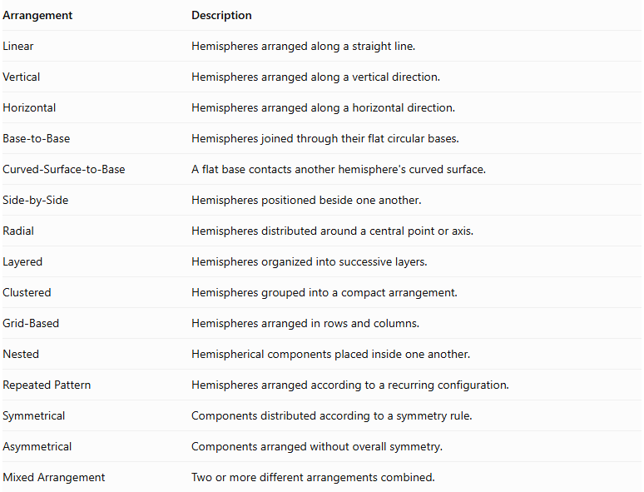
Arrangement | Description
Linear | Hemispheres arranged along a straight line.
Vertical | Hemispheres arranged along a vertical direction.
Horizontal | Hemispheres arranged along a horizontal direction.
Base-to-Base | Hemispheres joined through their flat circular bases.
Curved-Surface-to-Base | A flat base contacts another hemisphere's curved surface.
Side-by-Side | Hemispheres positioned beside one another.
Radial | Hemispheres distributed around a central point or axis.
Layered | Hemispheres organized into successive layers.
Clustered | Hemispheres grouped into a compact arrangement.
Grid-Based | Hemispheres arranged in rows and columns.
Nested | Hemispherical components placed inside one another.
Repeated Pattern | Hemispheres arranged according to a recurring configuration.
Symmetrical | Components distributed according to a symmetry rule.
Asymmetrical | Components arranged without overall symmetry.
Mixed Arrangement | Two or more different arrangements combined.

Classification by Number and Dimensions

By Number of Components
# Source: AI Source: Provided by: [Data Path: Persons Table -> ID Column: 1, Name_En Column: Motasem Essam] -> From: [ChatGPT] on [7/25/2026]
- Two-Hemisphere Composite Solid: Contains two hemispheres.
- Three-Hemisphere Composite Solid: Contains three hemispheres.
- Multiple-Hemisphere Composite Solid: Contains four or more hemispheres.

By Component Dimensions
# Source: AI Source: Provided by: [Data Path: Persons Table -> ID Column: 1, Name_En Column: Motasem Essam] -> From: [ChatGPT] on [7/25/2026]
- Equal-Radius Hemispheres: All hemispheres have the same radius.
- Different-Radius Hemispheres: Hemispheres have different radii.
- Equal-Diameter Hemispheres: All components have identical base diameters.
- Different-Diameter Hemispheres: Components have different base diameters.
- Equal-Volume Hemispheres: All hemispheres enclose the same volume.
- Different-Volume Hemispheres: Components enclose different volumes.

By Repetition Pattern
# Source: AI Source: Provided by: [Data Path: Persons Table -> ID Column: 1, Name_En Column: Motasem Essam] -> From: [ChatGPT] on [7/25/2026]
- Uniform Repetition: Identical hemispheres repeated at consistent intervals.
- Non-Uniform Repetition: Components repeated with varying dimensions or spacing.
- Single-Layer Repetition: Components arranged in one layer.
- Multi-Layer Repetition: Components arranged across multiple layers.
- Regular Repetition: Components follow a consistent geometric pattern.
- Irregular Repetition: Components follow a non-uniform pattern.

By Structural Type
# Source: AI Source: Provided by: [Data Path: Persons Table -> ID Column: 1, Name_En Column: Motasem Essam] -> From: [ChatGPT] on [7/25/2026]
- Solid Hemisphere-Based Structure: Formed from solid hemispherical components.
- Hollow Hemisphere-Based Structure: Formed from hollow hemispherical shells.
- Mixed Hemisphere-Based Structure: Combines solid and hollow hemispherical components.

Mathematical Properties and Formulas

Volume of One Hemisphere
# Source: AI Source: Provided by: [Data Path: Persons Table -> ID Column: 1, Name_En Column: Motasem Essam] -> From: [ChatGPT] on [7/25/2026]
The volume of a hemisphere is half the volume of a sphere.
$$V=\frac{1}{2}(\frac{4}{3}πr^{3})$$
$$\boxed{V=\frac{2}{3}πr^{3}}$$
Where:
- $V$ = Volume of the hemisphere.
- $r$ = Radius.
- $π≈3.14159$.

Volume of Multiple Equal Hemispheres
# Source: AI Source: Provided by: [Data Path: Persons Table -> ID Column: 1, Name_En Column: Motasem Essam] -> From: [ChatGPT] on [7/25/2026]
For $n$ identical hemispheres:
$$\boxed{V_{total}=\frac{2}{3}nπr^{3}}$$
Where:
- $n$ = Number of hemispheres.
- $r$ = Common radius.
This formula applies when the hemispheres do not overlap internally.

Volume of Multiple Different-Sized Hemispheres
# Source: AI Source: Provided by: [Data Path: Persons Table -> ID Column: 1, Name_En Column: Motasem Essam] -> From: [ChatGPT] on [7/25/2026]
When the hemispheres have different radii:
$$\boxed{V_{total}=\frac{2}{3}π\sum_{i=1}^{n}{r_{i}^{3}}}$$
Where $r_{i}$ represents the radius of each hemisphere.
If the components overlap, their overlapping volumes must be accounted for to calculate the volume of their combined union.

Curved Surface Area of One Hemisphere
# Source: AI Source: Provided by: [Data Path: Persons Table -> ID Column: 1, Name_En Column: Motasem Essam] -> From: [ChatGPT] on [7/25/2026]
$$\boxed{CSA=2πr^{2}}$$
This represents only the curved surface, excluding the flat circular base.

Total Surface Area of One Hemisphere
# Source: AI Source: Provided by: [Data Path: Persons Table -> ID Column: 1, Name_En Column: Motasem Essam] -> From: [ChatGPT] on [7/25/2026]
The total surface area includes the curved surface and the flat circular base.
$$TSA=2πr^{2}+πr^{2}$$
$$\boxed{TSA=3πr^{2}}$$

Surface Area of Multiple Separate Equal Hemispheres
# Source: AI Source: Provided by: [Data Path: Persons Table -> ID Column: 1, Name_En Column: Motasem Essam] -> From: [ChatGPT] on [7/25/2026]
For $n$ separate, identical hemispheres:
$$\boxed{{SA}_{total}=3nπr^{2}}$$
Their combined curved surface area is:
$$\boxed{{CSA}_{total}=2nπr^{2}}$$

Surface Area of Joined Hemispheres
# Source: AI Source: Provided by: [Data Path: Persons Table -> ID Column: 1, Name_En Column: Motasem Essam] -> From: [ChatGPT] on [7/25/2026]
When two hemispheres are joined through their complete circular bases:
- The two circular bases become hidden.
- The curved surfaces remain exposed.
- The joining area must not be counted as an external surface.
For two identical hemispheres joined base-to-base:
$$V=\frac{4}{3}πr^{3}$$
$$\boxed{SA=4πr^{2}}$$
The resulting structure is a complete sphere.
For a collection of equal hemispheres connected through $m$ complete matching circular-base interfaces:
$$\boxed{SA=3nπr^{2}-2mπr^{2}}$$
This formula assumes each joining interface is a complete circular base and that no other surfaces overlap.

Volume and Surface Area Summary
# Source: AI Source: Provided by: [Data Path: Persons Table -> ID Column: 1, Name_En Column: Motasem Essam] -> From: [ChatGPT] on [7/25/2026]
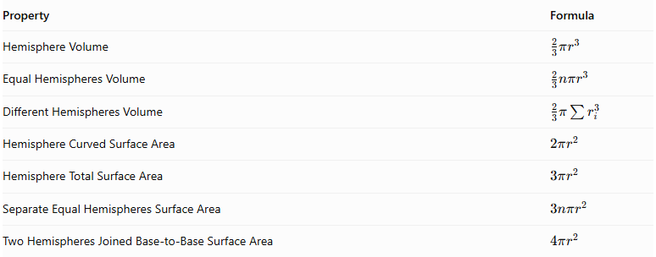
Property | Formula
Hemisphere Volume | $$\frac{2}{3}πr^{3}$$
Equal Hemispheres Volume | $$\frac{2}{3}nπr^{3}$$
Different Hemispheres Volume | $$\frac{2}{3}π\sum{r_{i}^{3}}$$
Hemisphere Curved Surface Area | $$2πr^{2}$$
Hemisphere Total Surface Area | $$3πr^{2}$$
Separate Equal Hemispheres Surface Area | $$3nπr^{2}$$
Two Hemispheres Joined Base-to-Base Surface Area | $$4πr^{2}$$

Worked Examples

Example 1: Three Identical Hemispheres Arranged in a Row
# Source: AI Source: Provided by: [Data Path: Persons Table -> ID Column: 1, Name_En Column: Motasem Essam] -> From: [ChatGPT] on [7/25/2026]
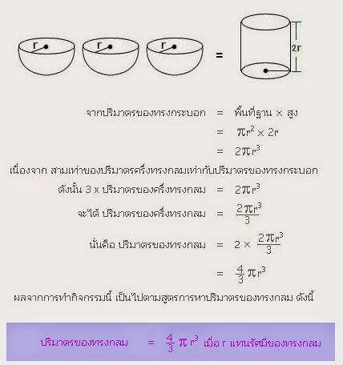
Given:
- Number of hemispheres: $n=3$
- Radius of each hemisphere: $r=2 cm$
- The hemispheres are separate and do not overlap.
Step 1: Calculate the volume of one hemisphere.
$$V=\frac{2}{3}πr^{3}$$
$$V=\frac{2}{3}π(2)^{3}$$
$$V=\frac{16}{3}π{ cm}^{3}$$
Step 2: Calculate the total volume.
$$V_{total}=3×\frac{16}{3}π$$
$$\boxed{V_{total}=16π≈50.27{ cm}^{3}}$$
Step 3: Calculate the total surface area.
Each separate hemisphere has:
$$TSA=3πr^{2}$$
$$TSA=3π(2)^{2}=12π$$
For three hemispheres:
$${SA}_{total}=3×12π$$
$$\boxed{{SA}_{total}=36π≈113.10{ cm}^{2}}$$
<badge color="success">Final Answer</badge>
- Total Volume = $16π≈50.27{ cm}^{3}$
- Total Surface Area = $36π≈113.10{ cm}^{2}$

Example 2: Four Identical Hemispheres Joined in Two Base-to-Base Pairs
# Source: AI Source: Provided by: [Data Path: Persons Table -> ID Column: 1, Name_En Column: Motasem Essam] -> From: [ChatGPT] on [7/25/2026]
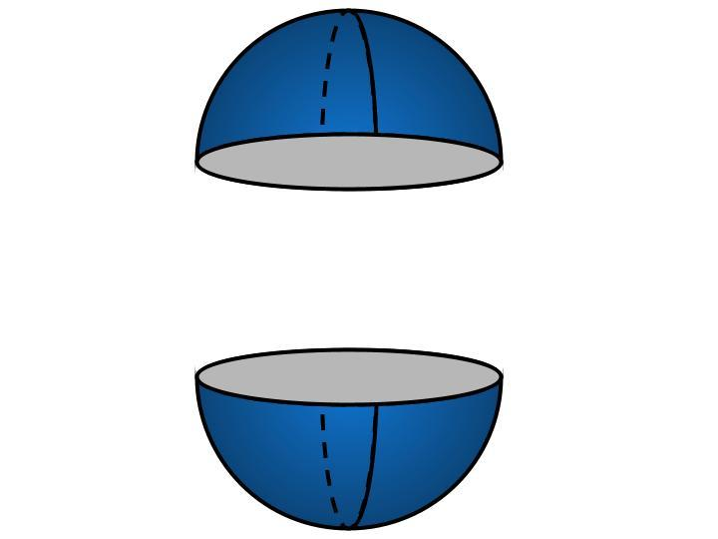
Given:
- Number of hemispheres: $n=4$
- Radius of each hemisphere: $r=3 cm$
- The hemispheres form two pairs.
- Each pair is joined through its complete circular bases.
Step 1: Calculate the volume of one hemisphere.
$$V=\frac{2}{3}πr^{3}$$
$$V=\frac{2}{3}π(3)^{3}$$
$$V=18π{ cm}^{3}$$
Step 2: Calculate the total volume.
$$V_{total}=4×18π$$
$$\boxed{V_{total}=72π≈226.19{ cm}^{3}}$$
Step 3: Calculate the external surface area.
Each pair forms a complete sphere.
The surface area of one sphere is:
$$SA=4πr^{2}$$
$$SA=4π(3)^{2}=36π$$
There are two complete spheres:
$${SA}_{total}=2×36π$$
$$\boxed{{SA}_{total}=72π≈226.19{ cm}^{2}}$$
<badge color="success">Final Answer</badge>
- Total Volume = $72π≈226.19{ cm}^{3}$
- External Surface Area = $72π≈226.19{ cm}^{2}$

Important Characteristics
# Source: AI Source: Provided by: [Data Path: Persons Table -> ID Column: 1, Name_En Column: Motasem Essam] -> From: [ChatGPT] on [7/25/2026]
- A hemisphere has one curved surface and one flat circular base.
- Its height is equal to its radius.
- Its volume is half the volume of a sphere with the same radius.
- Two identical hemispheres joined through their circular bases form a complete sphere.
- Repeated hemispheres may have equal or different dimensions.
- Their arrangements may be regular, irregular, symmetrical, or asymmetrical.
- Multiple hemispheres may form layered, radial, linear, or clustered structures.
- The circular joining bases become internal when two hemispheres are completely joined base-to-base.
- Point contact between curved surfaces hides no finite surface area.
- Overlapping or intersecting hemispheres require special calculations for their combined volume and external surface area.

Comparison with Other Repeated Composite Solids
# Source: AI Source: Provided by: [Data Path: Persons Table -> ID Column: 1, Name_En Column: Motasem Essam] -> From: [ChatGPT] on [7/25/2026]
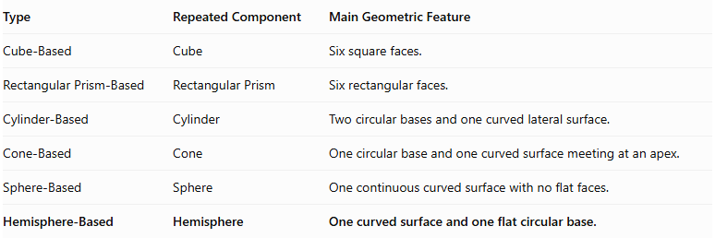
Type | Repeated Component | Main Geometric Feature
Cube-Based | Cube | Six square faces.
Rectangular Prism-Based | Rectangular Prism | Six rectangular faces.
Cylinder-Based | Cylinder | Two circular bases and one curved lateral surface.
Cone-Based | Cone | One circular base and one curved surface meeting at an apex.
Sphere-Based | Sphere | One continuous curved surface with no flat faces.
Hemisphere-Based | Hemisphere | One curved surface and one flat circular base.

Applications
# Source: AI Source: Provided by: [Data Path: Persons Table -> ID Column: 1, Name_En Column: Motasem Essam] -> From: [ChatGPT] on [7/25/2026]
Hemisphere-based repeated composite structures appear in:
- Architecture: Repeated hemispherical domes and roof structures.
- Construction: Dome-shaped structural elements.
- Mechanical Engineering: Hemispherical components and protective covers.
- Product Design: Rounded housings and decorative structures.
- Industrial Design: Repeated hemispherical forms in manufactured products.
- Landscape Design: Decorative hemispherical structures and garden features.
- Computer Graphics: Modeling repeated dome-shaped objects.
- Mathematics Education: Studying volume, surface area, symmetry, and spatial arrangements.

Key Points
# Source: AI Source: Provided by: [Data Path: Persons Table -> ID Column: 1, Name_En Column: Motasem Essam] -> From: [ChatGPT] on [7/25/2026]
- Hemisphere-based repeated composite solids consist of two or more hemispheres arranged in a repeated pattern.
- Common arrangements include linear, stacked, base-to-base, radial, layered, clustered, grid-based, and nested.
- Hemispheres may have equal or different radii.
- The volume of one hemisphere is:
$$V=\frac{2}{3}πr^{3}$$
- The curved surface area is:
$$CSA=2πr^{2}$$
- The total surface area is:
$$TSA=3πr^{2}$$
- Two identical hemispheres joined base-to-base form a complete sphere.
- External surface-area calculations must exclude hidden joining surfaces.
- Overlapping components require corrections to avoid double-counting.

Conclusion
# Source: AI Source: Provided by: [Data Path: Persons Table -> ID Column: 1, Name_En Column: Motasem Essam] -> From: [ChatGPT] on [7/25/2026]
Hemisphere-Based Repeated Composite Solids are three-dimensional structures formed by arranging multiple hemispheres in different geometric patterns. They can be linear, stacked, radial, layered, clustered, nested, symmetrical, or irregular.
Their mathematical properties are based on the volume and surface-area formulas of a hemisphere. Understanding how the hemispheres are arranged and connected is essential for calculating the total volume and external surface area accurately.

